**DOAS instrument and SpecScan Manual**

**Hardware**

*Overview*

The DOAS instrument’s internal components are displayed in Figure 1.

The principle component of the DOAS scanning instrument is the spectrometer. This measures light which is coupled to it via a scanning mirror directing light onto a lens, which in turn focuses the light onto an optical fiber. The other end of the optical fiber (which is has a slit shape to match the slit of the spectrometer entrance) is attached to the spectrometer. The spectrometer is an Ocean Insight (formerly Ocean Optics) Flame-S. The spectrometer slit entrance is 50 µm wide, with the optical bench set up to provide a spectral range of ≈240-400 nm and a spectral resolution of ≈0.65 nm (defined as the full-width at half maximum of an emission line peak – this so-called instrument line shape may change depending on which peak you look at and will be different for each individual spectrometer). The Sony ILX511 detector is a linear array CCD with 2048 elements and 16-bit ADC (65536 digital numbers).

IMPORANT: The optical fiber is very fragile and its internal structure can be broken if it is bent too much. Keep bending of this fiber to a minimum and never cause sharp angles or kinks in the fiber.

The scanning of the instrument is performed using a mirror mounted to a stepper motor which is housed in the external 3D-printed scanner head. The stepper motor is connected to a stepper motor driver board within the Peli Case, which must be linked to both a 12V battery (not included), to power the stepper motor, and an Arduino for stepper motor control. The Arduino and spectrometer are connected to a USB hub, which is connected to a single external USB connector. This allows simultaneous control of both the Arduino and the spectrometer from a single USB connection from a computer. For automation, a rather than using a laptop connected to the external USB port, a Raspberry Pi computer can be connected to the USB Hub internally with a USB cable. This will need to be powered separately to the stepper motor. Due to space limitations inside the box, batteries may need to be placed externally.

Figure 2. Stepper motor driver

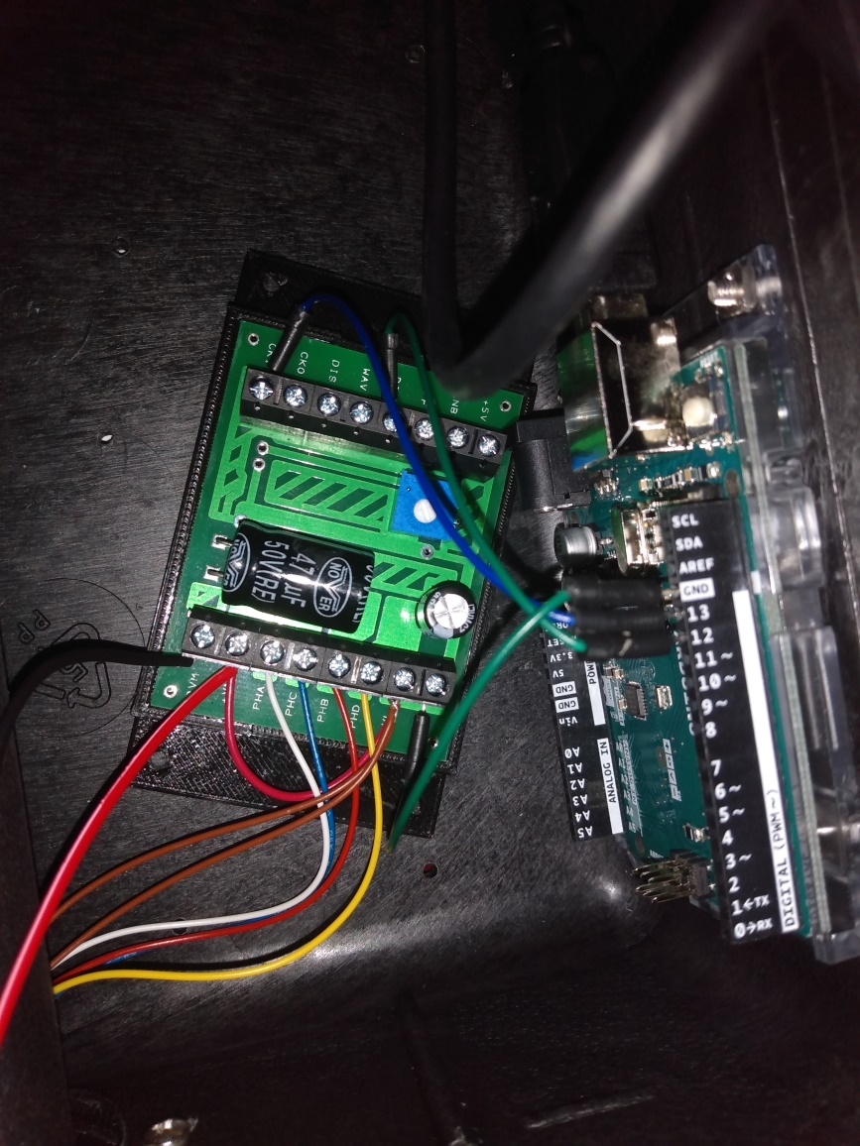

*Stepper motor battery connection*

To supply the stepper motor with power a 12V battery must be connected to the stepper motor driver (housed within the black box). The positive terminal of the battery must be connected to the +VM connection, whilst also keeping the loop wire to +VL in place. The negative terminal of the batter must be connected to the 0VM node.

+VM

Positive terminal

0VM

Negative terminal

*External optics*

The external optics comprise a mirror attached to a stepper motor which is housed at the end of the external head. There is then a UV transmissive curved window to protect the mirror. Please be careful with this window and try to prevent scratches which may affect the quality of light transmission. During transport, the head should be protected in some way if possible, for example with foam or bubble wrap.

*Long term deployment*

For long term deployment, if possible it is recommended that the box is shaded in some way, since significant changes (from direct sunlight) can cause the spectrometer calibration to change, and therefore will affect the measurements and their uncertainty. Some form of shading panel could be positioned above the box, whilst ensuring that this panel does not obstruct the view of the scanner head, which must be scanning across the sky unobstructed by overhead objects.

Orientation of the instrument depends on the geometry of the volcano and surroundings, the location of other instruments, and the objectives of deployment. It is preferable to ensure that the first scan point will be in clear sky and lies above the horizon. This is because the automated processing software assumes that the first spectrum is clear sky, and if it is in fact ground or in the plume, it will cause very inaccurate results. This can be corrected for using additional post processing, which designated the clear-sky spectrum manually, but this will require more user input and therefore will be more labour intensive.

The instrument should be very firmly secured to the ground, to prevent shake during windy periods.

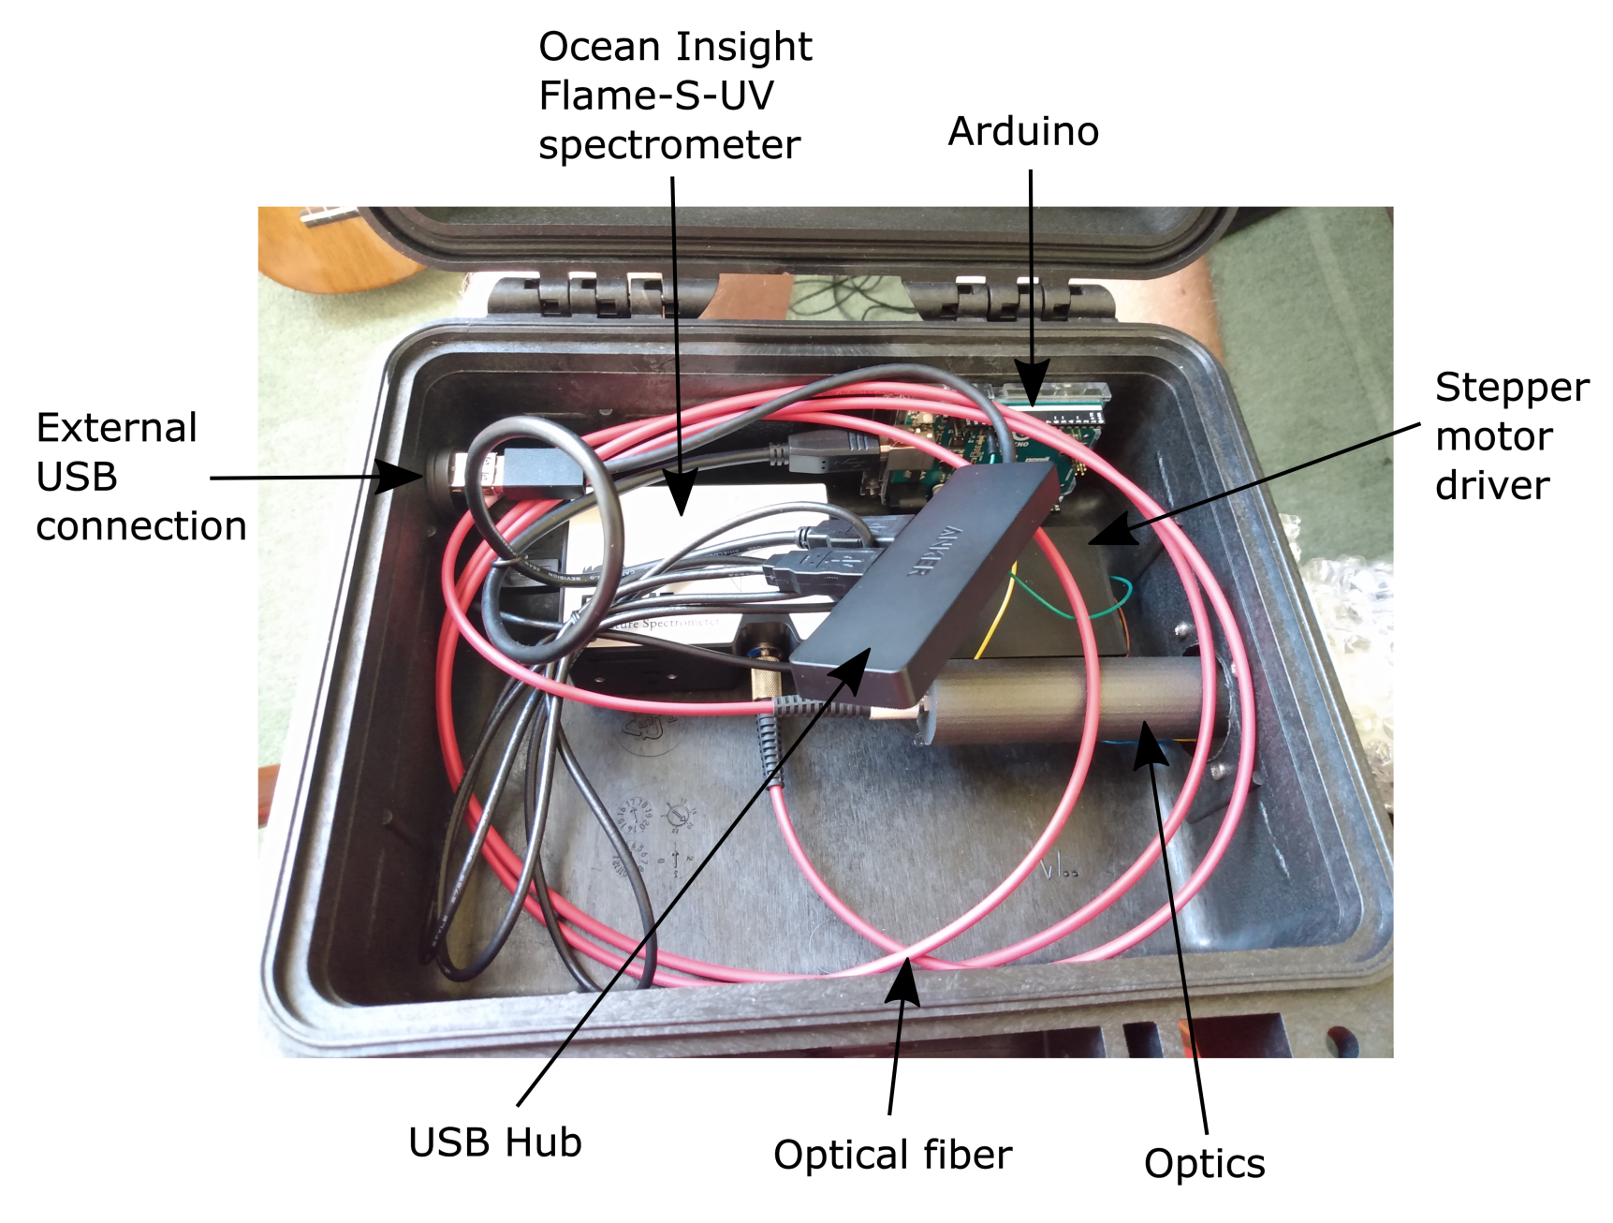

Figure 1. DOAS instrument internal components

**Software**

*Installation*

SpecScan is located at <https://github.com/twVolc/spec-scan>, where it can be freely downloaded.

Run **spec_scan.py** for local control of the spectrometer (from a Windows computer) and also for post-processing of spectra. Please ensure that you have Python 3.x (I use 3.8) installed and all **spec_scan** module requirements. The external module package requirements are listed in the **README.md** file, but I may have missed some. The full list should be found in the **requirements.txt** file, but this may contain more than is necessary. I would recommend installing what the README.md requests (including Anaconda) and then trying to run **spec_scan.py**. If you are still missing required modules, Python will tell you.

Once downloaded, please make a new folder within spec-scan folder titled “Spectra”. This will be used for the default place to save spectra.

Some **spec_scan.py** settings can be edited using the **config.txt file**. When changing settings, such as figure sizes, ensure the format is kept the same, e.g. do not introduce new whitespace into the file, this may cause errors for the program.

*Local control*

The instrument can be used directly in the field using a Windows laptop connected to the instrument via the external USB connector. This is currently the typical way to use this instrument (for further development to automate the instrument see the *Instrument Automation* section).

Firstly, you may need to change the COM port defined in the **config.txt** file to ensure that the setting corresponds to the COM port associated with the Arduino on your Windows machine. The correct COM number can be found in the Device Manager application on the Windows machine, then go to “Ports”.

Once the program has started and connected to the instrument correctly, acquisition is possible using the “Acquisition Settings” panel of the Main tab. Full scans can be acquired using scan mode, which will automatically acquire a dark spectrum at the start of the scan. Ensure that the integration time is set to a value such that the spectrum signal within the desired DOAS retrieval window is high but not saturated.

*Instrument Automation*

For automation, the SpecScan repository has an automation directory. These files are already loaded onto the Raspberry Pi microSD cards which contain the Raspberry Pi operating system. The **auto_capture.py** script must be run on the Raspberry Pi, whilst the Pi is connected to the DOAS instrument (see Hardware section) and this will then automatically control scan acquisitions from the instrument continuously until the program is stopped. Spectra are saved locally in **./Spectra/<date>/Scan_x/** folders onto the Raspberry Pi. From here, you should control transmission of the Scan folders back to wherever you need the data transmitting to. The **Scan_x** directory will contain a **scan.lock** file which remains present until that scan has been completed by the instrument – when the scan is complete this file is removed – the scan is then ready for transmission away from the instrument.

IMPORTANT: Please test this auto_capture.py script thoroughly before deploying in the field – this has been a new software development which has only been tested for a short time in University of Sheffield.

I would recommend having some additional program on the Raspberry Pi which starts and stops the auto_capture.py program at the start of each day (you do not want/need the DOAS instrument running in the night).

*Post-processing setup*

For post-processing of spectra on the base station machine use **spec_scan.py**. This is a relatively simple program which should only require a small amount of setup to automatically process data as it arrives. Use the directory watcher (see Figure 2) to setup a directory where all date and scan directories will be copied to (I recommend maintaining the folder structure employed on the Raspberry Pi **./Spectra/<date>/Scan_x/**). Select this folder with “Select Directory” and then start watching this folder by clicking “Start Watching”. The program will now be waiting for new files/folders to arrive, and will then process and plot them in the figures as they arrive at the computer. IMPORTANT: When the transmission of a scan from the instrument to the local machine is complete, you must make one more file named **complete.txt** and add this to the scan folder (the file can be empty, but it must exist). The directory watcher is waiting for this file to appear and will only start processing the scan once it finds this file in the folder. Ensure it is the last file you write to the folder, as otherwise the directory watcher will begin processing before all spectra have arrived at the machine.

A different instance of **spec_scan.py** must be used for each DOAS instrument. Furthermore, prior to beginning processing (before setting up the directory watcher), you must set up the instrument line shape (ILS) calibration. Go to the calibration tab and then click “Load ILS” (see Figure 3). You must find the ILS associated with the spectrometer that this program will be working with. The ILS calibration spectra have been place on the Raspberry Pi microSD cards, so please copy these files onto your local Windows machine so that they can be loaded into the **spec_scan** software. I recommend placing these files in the **./Calibration_files/** directory. To change the default start-up file which is loaded for the ILS, go to the **config.txt** file and change the ILS= line to contain the relative or absolute path to the ILS file you wish to use; you must maintain the apostrophes around the file path. e.g. if I wanted to change the file to read in a file with the name **new_ILS.txt**, which I have placed in the **./Calibration_files** folder, I would edit the config.txt line to read: **ILS='.\Calibration_files\new_ILS.txt'**.

IMPORTANT: The ILS files are saved with the model number of the spectrometer, which can be found on the side of the spectrometer, so please ensure that you are using the correct ILS loaded into **spec_scan** with the correct instrument, otherwise errors in the DOAS retrievals will occur.

*Post-processing*

For detailed information on the DOAS processing procedure please read about DOAS in volcanology in the literature (e.g. Galle et al. (2002) *A miniaturised ultraviolet spectrometer for remote sensing of SO2 fluxes: a new tool for volcano surveillance;* Platt and Stutz (2008) Differential Optical Absorption Spectroscopy). This section cannot provide a detailed overview of DOAS, and only explains some details of how the software works.

Spectra will be loaded and displayed in the top figure of the main tab, including the dark and clear-sky spectra. The wavelength fitting range has a default of 305-320 nm and I would suggest not changing this unless you are sure that it needs adjusting. It can be adjusted using the boxes in the top-right corner of the figure. Similarly, the stray-light correction range can be adjusted, but this should not need changing. Stray light corrects for signal within the spectrometer which should not be present. We use a range where there should be no light coming from the sky, due to ozone absorption, so any signal present in the spectrometer at these wavelengths is due to stray light; we therefore, take an average of this signal to correct the entire spectrum, assuming stray light is constant across the detector.

The figure below displays the DOAS retrieval, with the measured and fitted reference spectra. We use only SO2 and O3 reference spectra in the fit. The column density and standard error of the fit is displayed in the title of the figure. Options to shift/stretch the spectra are provided, however, it is recommended that this is avoided unless you are confident with what you are doing. **spec_scan** has a built-in shift tolerance of 2, so it will automatically shift the spectra 2 pixels each way and pick the best fit value (lowest std err) as the correct retrieval; in most scenarios this level of shift should be adequate.

The next figure plots the scan column densities and associated scan angle (relative to starting angle). NOTE: it is unlikely that the first spectra is acquired horizontally (at an angle of 0˚), so these angles are only relative, and do not represent the true inclination of the optics. The angle will depend on instrument set up in the field. At the end of the scan, the emission rate is provided in the box (these are also all saved in the associated scan directory in a processing folder). IMPORTANT: The emission rate depends strongly (linearly) on the plume speed and also has a strong dependence on the distance between the instrument and the plume. The DOAS instrument is not capable of making these measurement, and it will depend on the conditions on the day and the positioning of the instrument relative to the volcano. Many researchers/monitoring teams use modelled wind speed data, weather station data, or a network of DOAS instruments which can calculate plume distance through trigonometry and plume speed through cross-correlation. Plume distance can be difficult to determine; depending on the instrument setup in the field, it may be possible to assume a constant distance, otherwise other methods of retrieving plume distance, such as modelling or using multiple instruments simultaneously, may be needed. Currently, there is no method of automatically changing the plume speed and distance parameters in the **spec_scan.py** software, although if this is required it could be implemented. Recommended reading for possible solutions to plume height and plume speed determination: Galle et al. (2010) Network for Observation of Volcanic and Atmospheric Change (NOVAC)—A global network for volcanic gas monitoring: Network layout and instrument description. The final figure plots a time series of the day’s emission rate data. At the end of each day the time series is saved and a new time series will be generated.

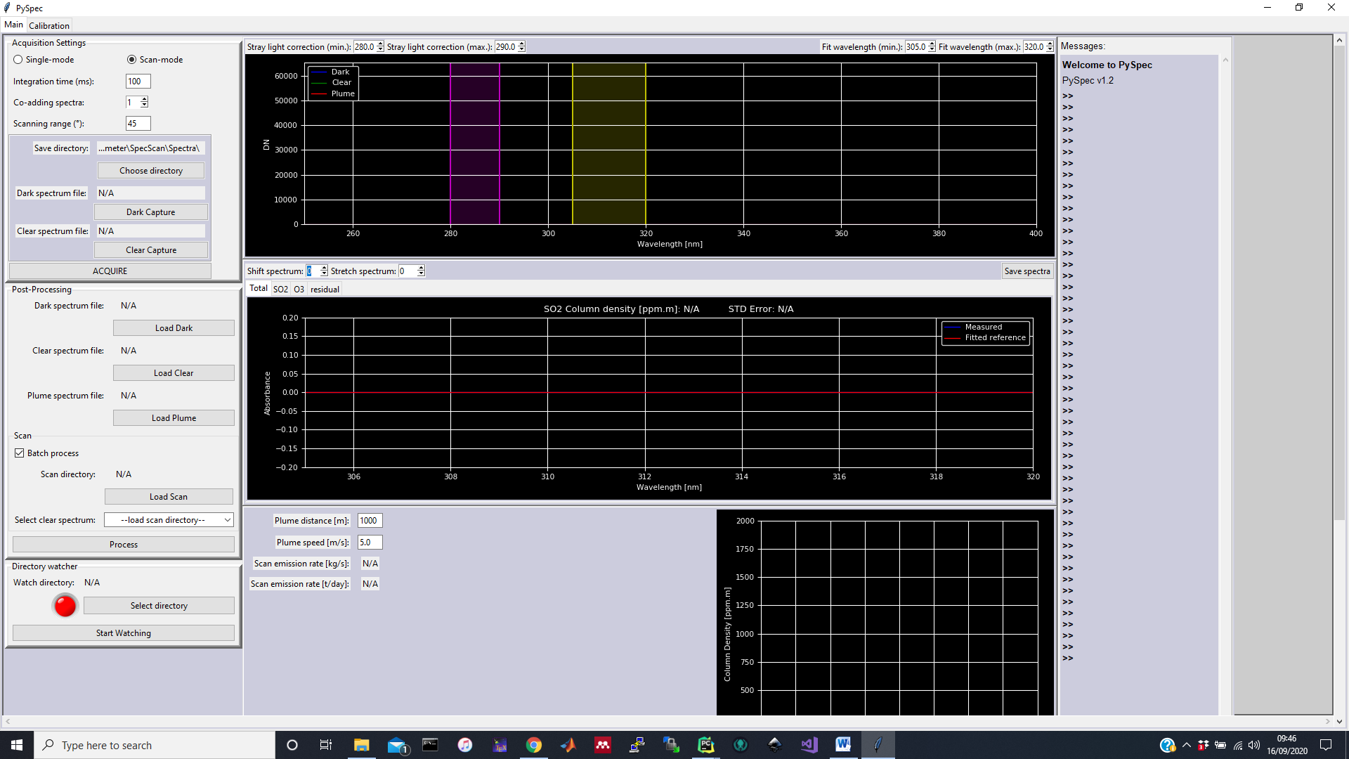

Figure 2. spec_scan main tab with the directory watcher for automated processing highlighted

Directory watcher for automated processing

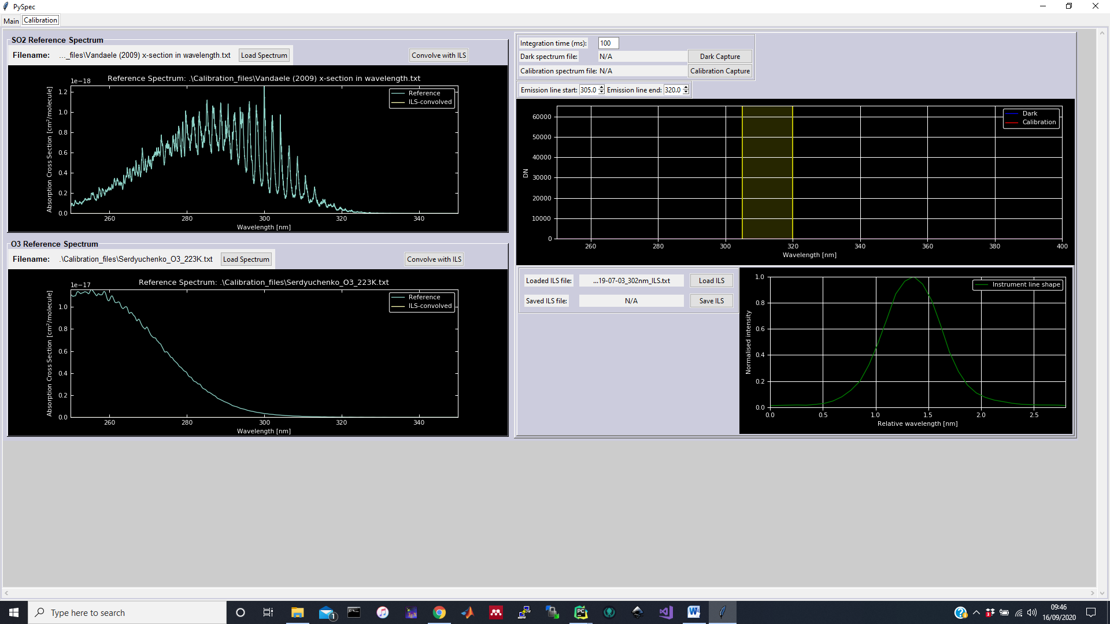

Instrument line shape calibration. Must be set up for each DOAS instrument separately because each spectrometer has its own ILS.

Calibration tab

Figure 3. spec_scan calibration tab with instrument line shape loading highlighted